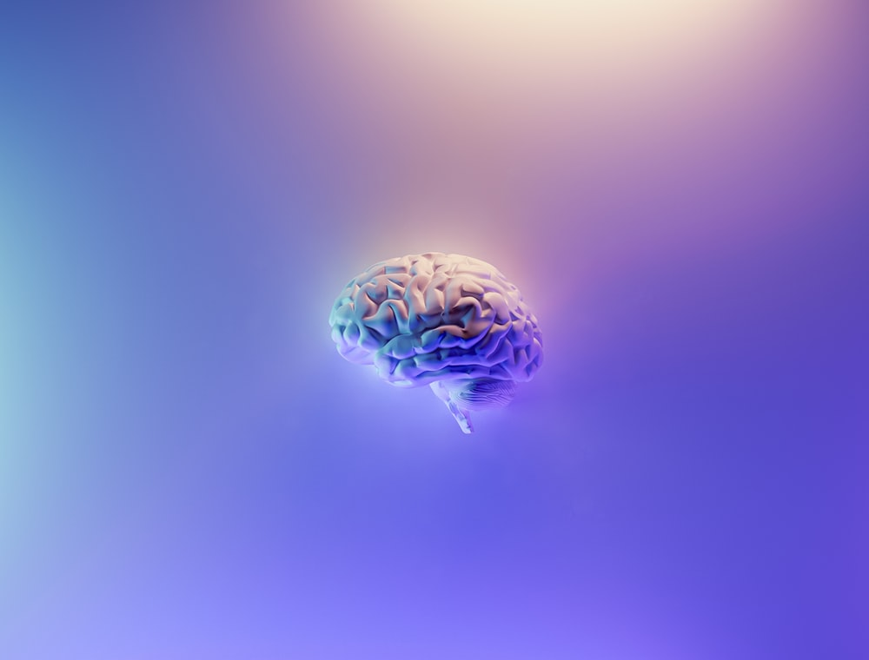

Brain MRI Segmentation

Using U-NET Architecture

Kunal Kadam | A.I. Project | 18 April 2022

# Problem Statement

A brain tumor is a mass or growth of abnormal cells in your brain. Primary brain tumors originate in the brain itself or in tissues close to it, such as in the brain-covering membranes (meninges), cranial nerves, pituitary gland or pineal gland. Primary brain tumors begin when normal cells develop changes (mutations) in their DNA. A cell's DNA contains the instructions that tell a cell what to do. The mutations tell the cells to grow and divide rapidly and to continue living when healthy cells would die. The result is a mass of abnormal cells, which forms a tumor. The signs and symptoms of a brain tumor vary greatly and depend on the brain tumor's size, location and rate of growth. Many brain tumor symptoms and brain cancer symptoms are similar to those of other diseases and conditions. If you are diagnosed with a brain tumor, a doctor will take a treatment decision depending on the size and part of brain affected. Treatment aims to either remove the tumor completely, slow its growth or relieve symptoms by shrinking the tumor.

Suggestions for treatment will be based on:

* your age, health and medical history
* the type, location and size of the tumor
* how fast the tumor is growing, and how likely it is to spread or come back
* your symptoms
* how you may react to different therapies

Patient may be referred to specialists including:

* [oncologist](https://www.healthdirect.gov.au/what-is-an-oncologist) (cancer specialist)
* [neurologist](https://www.healthdirect.gov.au/what-does-a-neurologist-do) (brain specialist)
* [neurosurgeon](https://www.healthdirect.gov.au/what-does-a-neurosurgeon-do) (brain surgeon)

The main treatments for brain tumors are:

* surgery
* [radiotherapy](https://www.healthdirect.gov.au/radiotherapy)
* [chemotherapy](https://www.healthdirect.gov.au/chemotherapy)
* medications to control symptoms

The main challenge faced by the doctors is diagnosis of the tumor as early as possible. So that the patient can start the treatment. Here comes the main problem faced by many of the doctors to accurately predict the tumor in the brain and the position where the tumor is present. Through out this project we will try to find a solution for this problem with the help of Artificial Intelligence.

# Ideate Solution

Give a problem statement we can now began with the lifecycle of Machine Learning.

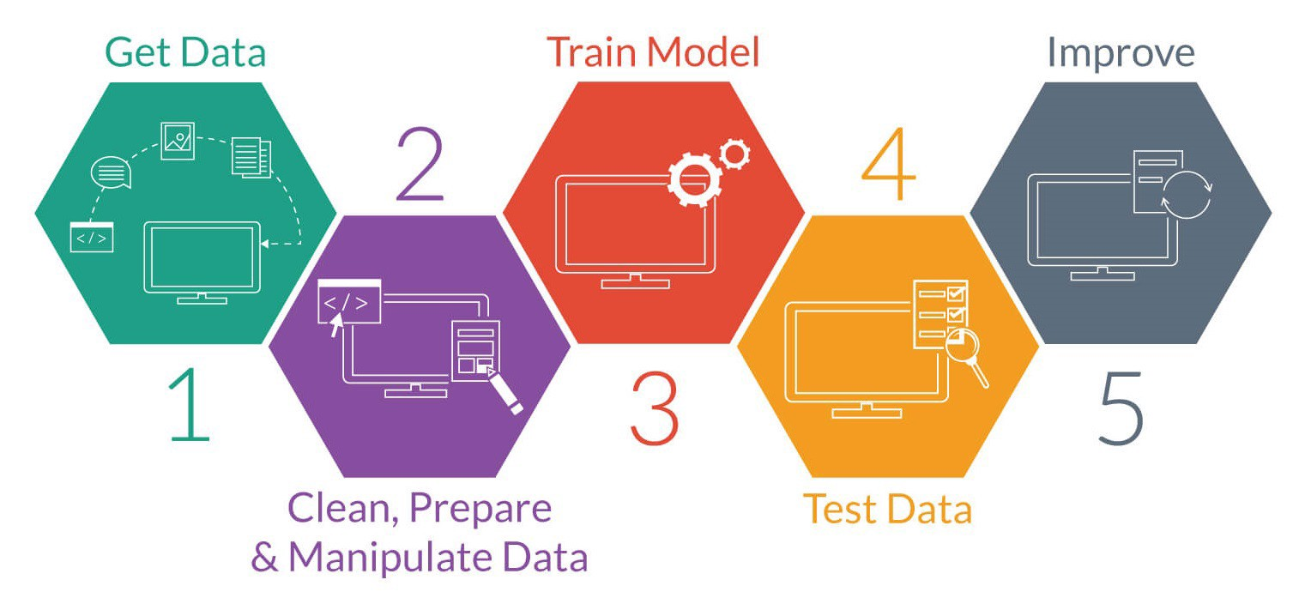

Machine Learning Lifecycle

**Get Data**

The data required for solving the problem need the MRI images of the brain along with the segmentation mask that has localized the exact part where the tumor is present. In search of this data I had rendered several online sites. Lastly, I got one related kernel on Kaggle for the project. The kernel contains the data recorded from 110 patients which contains there MRI images along with there mask images. The data.csv files also contains the information about the patients there various clusters recorded.

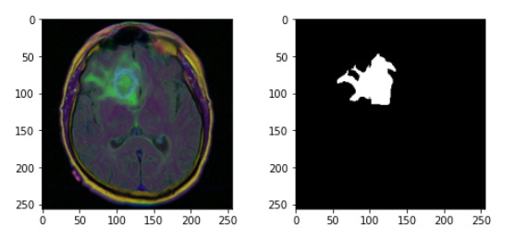

MRI Image Mask Image

**Data Preparations**

The images we require for training must have the mask image present for calculation of the loss. So, the first major task was to filter out only those MRI’s that have the mask images present. Then we converted the images from .tff to .nii format since it is a very efficient way when using **monai** or with medical data in general. After that Converting the colored images into Grayscale images since, it will reduce the model complexity a lot.

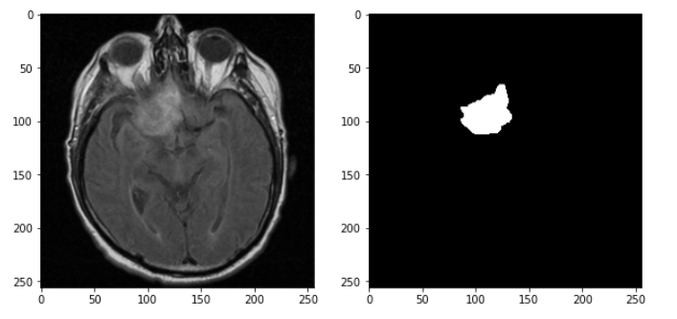

Modified MRI Image Mask Image

**Train Model**

The framework used for this project was **MONAI** (Medical Open Network for Artificial Intelligence). The main use of this framework was to provide domain-optimized foundational capabilities for developing healthcare imaging training workflows in a native **PyTorch** paradigm. This PyTorch-based framework for deep learning in healthcare imaging. The architecture that I had selected for this project is a popular architecture used for medical image segmentation called **U-Net Architecture**. U-Net is a convolutional neural network that was developed for biomedical image segmentation at the Computer Science Department of the University of Freiburg. The data was divided in to training set and the testing set in ratio of 7:3. The entire model was trained using the GPU power so to load the model as well as the data in the GPU I had written the code for DataLoader. Once all requirements were satisfied. I had done an iterative experiment to find the best number of epoch and the other hyper params to get the least loss as much possible. I found that we require 40 epochs to train the entire model with loss function as DiceLoss function and optimizer as Adam optimizer. The input image was of pixel 128x128 that was passed through the model. At every epoch I had printed the loss on both the training set and the testing set.

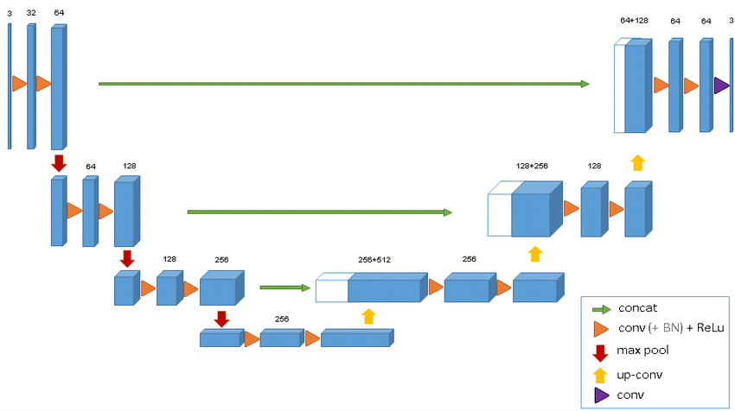

U-Net Architecture

**Test Data / Result**

Since looking at the complexity of the problem I found that my model was able to predict the proper place where the tumor is located but still, I have to achieve a better accuracy. The possible way to further reduce the loss from 29% to less we have to implement some more complex architecture like Attention or Attention Residual U-Net architecture. Looking at the training time statistics like the **loss vs epoch** graph for both the training and the validating data I found that the applied process was correct.

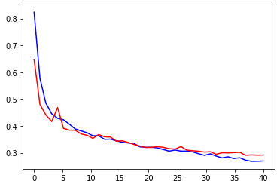

Loss VS Epoch Graph

Red – Validation Data

Blue – Train Data

# Application

The model used in this project was a good example to demonstrate the power of Artificial Intelligence. The model I tried to diagnosis the brain tumor is equally efficiently, if compared with the common man accuracy. In order to further improve it’s accuracy we need to shift to some more complex models and need to do the required image preprocessing for that case. The entire approach made in this project for diagnosis of the brain tumor is meaningful but not completely reliable. The further changes I am going to make can improve this accuracy and make it more reliable for doctors to use.

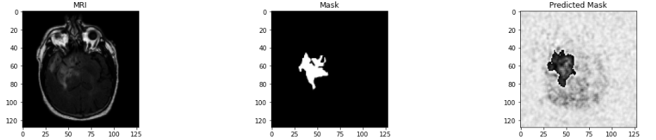

MRI Image Mask Image Predicted Mask

# References

Brain MRI Data - <https://www.kaggle.com/datasets/mateuszbuda/lgg-mri-segmentation>

Research Paper U-Net - [[1505.04597] U-Net: Convolutional Networks for Biomedical Image Segmentation (arxiv.org)](https://arxiv.org/abs/1505.04597)

Kaggle Notebook - <https://www.kaggle.com/code/kunalkadam/brain-mri-segmentation>

# Thank You.